==============================1 Issue =======================================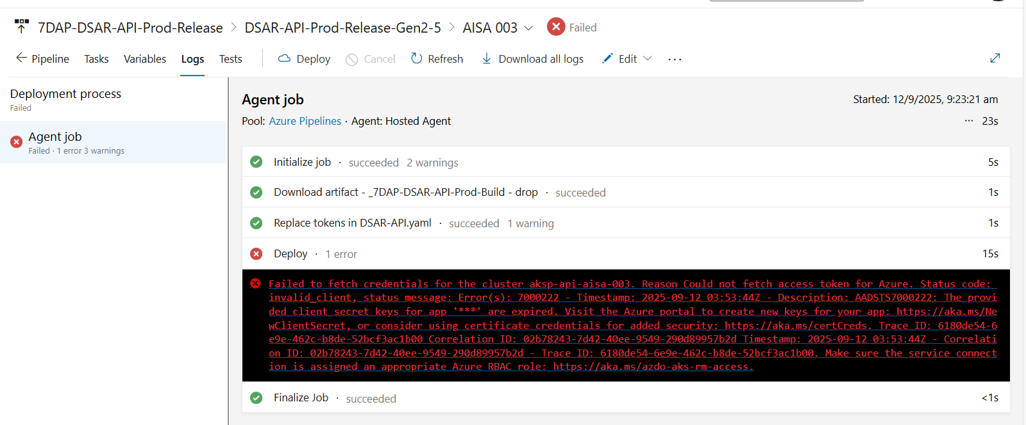
Error:-
Failed to fetch credentials for the cluster aksp-api-aisa-003. Reason Could not fetch access token for Azure. Status code: invalid_client, status message: Error(s): 7000222 - Timestamp: 2025-09-12 03:53:44Z - Description: AADSTS7000222: The provided client secret keys for app '***' are expired. Visit the Azure portal to create new keys for your app: https://aka.ms/NewClientSecret, or consider using certificate credentials for added security: https://aka.ms/certCreds. Trace ID: 6180de54-6e9e-462c-b8de-52bcf3ac1b00 Correlation ID: 02b78243-7d42-40ee-9549-290d89957b2d Timestamp: 2025-09-12 03:53:44Z - Correlation ID: 02b78243-7d42-40ee-9549-290d89957b2d - Trace ID: 6180de54-6e9e-462c-b8de-52bcf3ac1b00. Make sure the service connection is assigned an appropriate Azure RBAC role: https://aka.ms/azdo-aks-rm-access.

Resolution: - if the pipeline is failing due to this then change it to Kubernetes Service Connection. We have discussed this in past as well, not to use Azure Resource Manager for Kubernetes deployment, rather we need to use Kubernetes Service Connection.
Can you run the pipeline with that to resolve any blocker

Steps
Change the Service connection type to Kubernetes Service Connection, give the correct Kubernetes Service connection name according to the aks cluster, and rerun the pipeline

refer this pipeline- https://dev.azure.com/711StoreSystems/DataEngineering/_releaseDefinition?definitionId=463&_a=de…

============================2nd Issue =======================================
Service Desk - Kubernetes Contributor Access Issue
Type: Create / Modify an Azure resource Priority: High (Resolution within 2-3 business days) Details: AKS resources are not able to access the DDE-DEV-GEN2-DATALAKE-RAW-NAME, need to check the access keys provided.

Please find the below key vault names which is being used to connect to the storage account:
DL_CLIENT_ID_KEY: EDPG2DEVLAKERAW01-SP-CONTRIB-CLIENT-ID
DL_CLIENT_SECRET_KEY: EDPG2DEVLAKERAW01-SP-CONTRIB-CLIENT-SECRET
DL_RESOURCE_KEY: AZURE-DATALAKE-RESOURCE
DL_STORE_NAME: DDE-DEV-GEN2-DATALAKE-RAW-NAME
TENANT_ID_KEY: AZURE-DEV-TENANT-ID
Resolution: -
The error occurs while migrating adls storage Uc storage
So, need to whitelist aks vnet and subnet into new UC storage
Take the vnet details from below: -
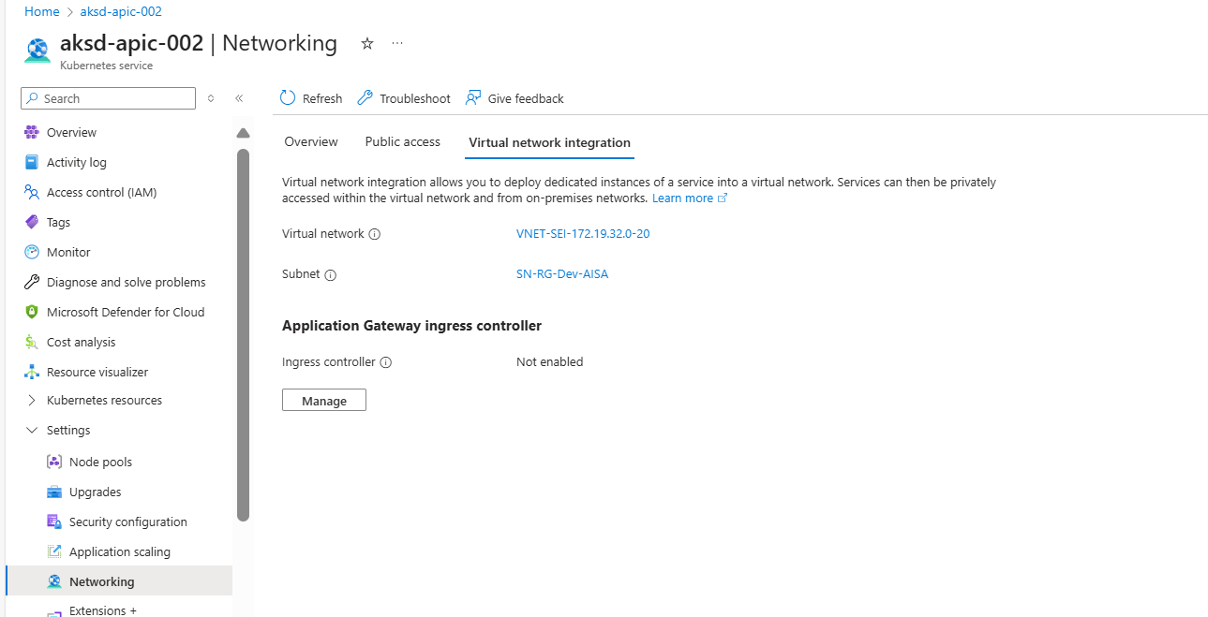

And whitelist in to relevant storage ac:-
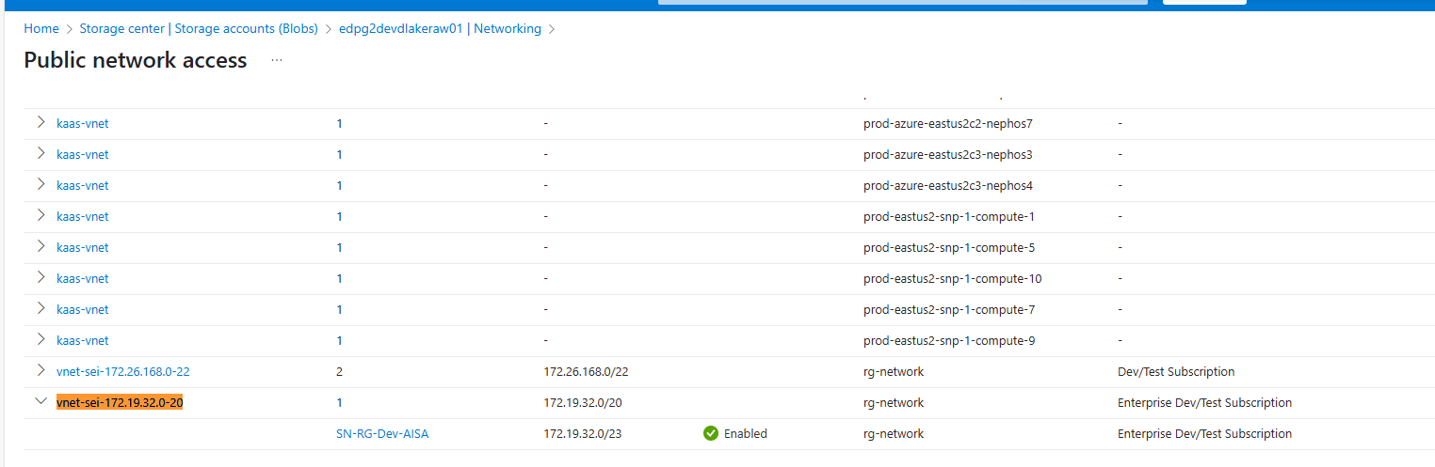

========================================================================================================================================================
kubectl scale deployment devops-companion-ui-dev --replicas=1
How to restart deployment

